Government College of Engineering
Aurangabad
SIX DAYS WORKSHOP
ON
“CMOS BASED RFIC DESIGN”
(28th JUNE TO 3rd JULY 2016)
Sponsored by TEQIP Phase II Under ASWS

REGISTRATION FORM

Name: _________________________________
Address For Communication: ______________________________________________________________________________________________________
Mobile No: _____________________________
E-mail: ________________________________
Educational Qualification: _________________________
Signature of Applicant

Signature of Head

PATRONS

Dr. S. J. Kunte
Dy. Secretary
Higher and technical education
Mantralaya , Mumbai
Dr. S. K. Mahajan
Director , Directorate of Technical Education,
Maharashtra State , Mumbai
Dr. Mahesh Shivankar
Joint Director, Technical Education ,
Regional Office , Aurangabad.
Dr. P. S. Adwani
Principal Govt. College of Engineering ,
Aurangabad
Chairman
Prof. R. P. Chaudhari
Head of E&TC Department
Prof. N. R. Kolhare
ORGANISING COMMITTEE

Dr. A S Bhalchandra Monica Jige
Dr. A. R. Karwankar Monika Shejwal
Prof. P. H. Bhagat TejashreeSalunke
Dr. V. R. Ratnaparkhe Monica Nagawade
Prof. S. S. Agrawal Renuka.sadar
Prof. S. D. Bharkad GovindKumbhakarna
Prof. S. R. Kulkarni SourabhPatil
Prof. S. B. Gundre SudhirIngole
Prof. M R Joshi VijayaNagargoje
Shri S. P. Joshi YogeshTaru
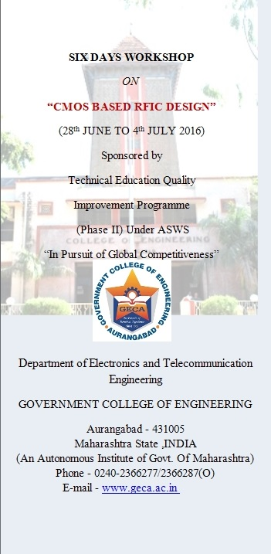

ABOUT WORKSHOP

CMOS (complementary metal oxide semiconductor) is a key digital integrated circuit technology that is widely used throughout the wireless communications industry. This practical resource offers comprehensive, expert guidance on designing CMOS RF integrated circuits. Professionals get complete design details on elemental and advanced CMOS RF circuits, from low noise amplifiers, general gain amplifiers, mixers, and oscillators, to voltage controlled oscillators, phase lock loops, frequency synthesizers, and power amplifier architectures. Engineers also find a review of RF system fundamentals and definitions of terms widely used in the field.

DATE AND VENUE

The WORKSHOP will be held during 28thjune -3rdjuly 2016 at ELECTRONICS DEPARTMENT SEMINAR HALL ,DEPARTMENT OF ELECTRONICS ,Govt. College of Engineering, Aurangabad.
RESOURCE PERSONS

Dr.JayantaMukharjee
IIT Bombay
Dr. Anita Murugkar
BAMU , Aurangabad

Prof. Anurag Nigam
(DIOEAMS), Aurangabad

COURSE CONTENTS

- SEMICONDUCTOR TECHNOLOGIES AND
SIMULATION TECHNIQUES.
- DIGITAL DESIGN IN CMOS
- ANALOG CIRCUITS
- RF SYSTEMS
- MICROWAVE PASSIVES AND ELECTROMAGNETICS
- ANTENNA AND RADIO FRONT END
REGISTRATION

Candidates should complete the enclosed registration form and send it by mail to the coordinator . Confirmation of eligible candidates will be on FIRST-COME-FIRST-SERVE basis upto a maximum of 40 candidates (APPROX). The complete registration form should be received by the coordinator by june24 , 2016. There is no registration fees for this workshop.
LECTURE NOTES

To fully realise the objectives of the course. The lecture notes will be made available.

ABOUT AURANGABAD

AURANGABAD is a historic , holy , and a place of tourism in a Marathwada region of Maharashtra State . Lord Ghrishneshwartemple ,BhadraMaruti , Saint EknathMaharaj temple , Daultabad Fort , Biwi-ka-Makbara , World famous Ajanta and Ellora Caves are in close proximity . The city is well connected by roads , rails , and air- route.

ADDRESS FOR CORRESPONDANCE

Department of ELECTRONICS &TELE-COMMUNICATION ENGINEERING ,
Govt. College of Engineering
Station Road ,Osmanpura
Aurangabad - 431005 (MS) India

For detail contact Ms Monica Jige-9420769223

